ISDC 2019b  
*System dynamics conference 2019*  
**February 14th 2020, 4:23 pm CET**

**Q0a - We would like to know more about your impressions of the 2019 International Conference of the System Dynamics Society in Albuquerque, New Mexico. For each of the following statements, please indicate your answer by selecting one of the options available. Most questions can be answered on a scale from 1 = very negative to 7 = very positive; no opinion.**



|  |  |  |  |  |  |  |  |
| --- | --- | --- | --- | --- | --- | --- | --- |
| # | Field | Minimum | Maximum | Mean | Std Deviation | Variance | Count |
| 1 | We would like to know more about your impressions of the 2019 International Conference of the System Dynamics Society in Albuquerque, New Mexico. For each of the following statements, please indicate your answer by selecting one of the options available. Most questions can be answered on a scale from 1 = very negative to 7 = very positive; no opinion. | 0.00 | 0.00 | 0.00 | 0.00 | 0.00 | 0 |

|  |  |  |
| --- | --- | --- |
| Answer | % | Count |
| Total | 100% | undefined |

**Q1 - When it comes to conference content my evaluation is:**

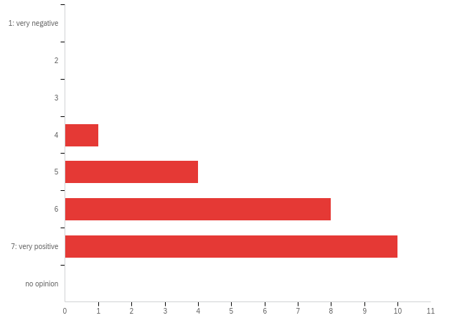

|  |  |  |  |  |  |  |  |
| --- | --- | --- | --- | --- | --- | --- | --- |
| # | Field | Minimum | Maximum | Mean | Std Deviation | Variance | Count |
| 1 | When it comes to conference content my evaluation is: | 4.00 | 7.00 | 6.17 | 0.87 | 0.75 | 23 |

|  |  |  |  |
| --- | --- | --- | --- |
| # | Answer | % | Count |
| 1 | 1: very negative | 0.00% | 0 |
| 2 | 2 | 0.00% | 0 |
| 3 | 3 | 0.00% | 0 |
| 4 | 4 | 4.35% | 1 |
| 5 | 5 | 17.39% | 4 |
| 6 | 6 | 34.78% | 8 |
| 7 | 7: very positive | 43.48% | 10 |
| 8 | no opinion | 0.00% | 0 |
|  | Total | 100% | 23 |

**Q1b - Additional comments**

|  |
| --- |
| Additional comments |
| relevant topics both for experienced practitioners and participants new to SD |
| The content is much better than Academy of Management (which is the only other conference I attend). |
| New ideas, enlarged interests, different profiles involved! |
| The teachers for the beginning summer school were not helpful to the real beginners. |
| I think I would have liked to have seen more a models, and the implications of those models. |
| enjoyed the people more than the presentations which were very mixed |
| Plenaries were generally very weak, especially those consisting of papers presented by society members (as opposed to the 'special' sessions like the panel on the field or presentation by policymakers). Many of the papers presented in the para sessions were better. |

**Q2 - When it comes to the services provided by the conference organization my evaluation is:**

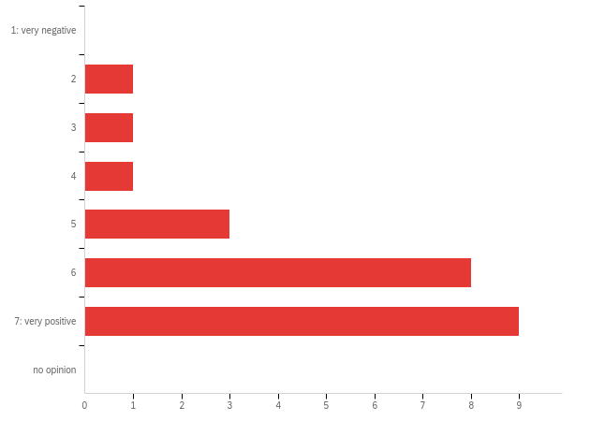

|  |  |  |  |  |  |  |  |
| --- | --- | --- | --- | --- | --- | --- | --- |
| # | Field | Minimum | Maximum | Mean | Std Deviation | Variance | Count |
| 1 | When it comes to the services provided by the conference organization my evaluation is: | 2.00 | 7.00 | 5.87 | 1.33 | 1.77 | 23 |

|  |  |  |  |
| --- | --- | --- | --- |
| # | Answer | % | Count |
| 1 | 1: very negative | 0.00% | 0 |
| 2 | 2 | 4.35% | 1 |
| 3 | 3 | 4.35% | 1 |
| 4 | 4 | 4.35% | 1 |
| 5 | 5 | 13.04% | 3 |
| 6 | 6 | 34.78% | 8 |
| 7 | 7: very positive | 39.13% | 9 |
| 8 | no opinion | 0.00% | 0 |
|  | Total | 100% | 23 |

**Q2b - Additional comments**

|  |
| --- |
| Additional comments |
| well organized, great venue (but expensive both venue and the conference!), very friendly, helpful and approachable organizers |
| Lunch could have been provided. Many participants late for the next session due to this issue. |
| Overall, I thought the conference was well organized. A minor inconvenience was that the hotel staff at times did not keep the coffee and tea fully stocked at all times. |
| lunch was missing |
| I liked the idea of fruit for snacks. |
| All the staff is super ! |

**Q3 - When it comes to conference geographical location my evaluation is:**

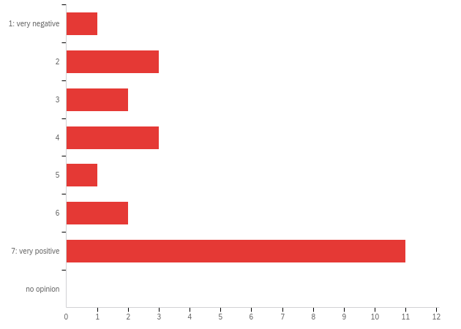

|  |  |  |  |  |  |  |  |
| --- | --- | --- | --- | --- | --- | --- | --- |
| # | Field | Minimum | Maximum | Mean | Std Deviation | Variance | Count |
| 1 | When it comes to conference geographical location my evaluation is: | 1.00 | 7.00 | 5.17 | 2.08 | 4.32 | 23 |

|  |  |  |  |
| --- | --- | --- | --- |
| # | Answer | % | Count |
| 1 | 1: very negative | 4.35% | 1 |
| 2 | 2 | 13.04% | 3 |
| 3 | 3 | 8.70% | 2 |
| 4 | 4 | 13.04% | 3 |
| 5 | 5 | 4.35% | 1 |
| 6 | 6 | 8.70% | 2 |
| 7 | 7: very positive | 47.83% | 11 |
| 8 | no opinion | 0.00% | 0 |
|  | Total | 100% | 23 |

**Q3b - Additional comments**

|  |
| --- |
| Additional comments |
| end of the world for anyone from EU, Africa, Middle East - very expensive and had to get to. |
| the place is hard to reach from the South in particular |
| Albuquerque was a quaint place to visit. |
| A wonderful location! I loved ABQ. |
| There was no direct flight. |
| Near Old town! |
| Even though the city of Albuquerque is interesting - It has not been the perfect city to walk around |
| too remote |
| Lovely city, but too far from many members and too difficult to get to. European participation was very low. The society has had a policy of holding conferences in locations with major international airports to minimize travel time and cost for participants. We should go back to this policy and enforce it for all conference going forward. |

**Q45 - When it comes to the conference venue (building and facilities) my evaluation is:**

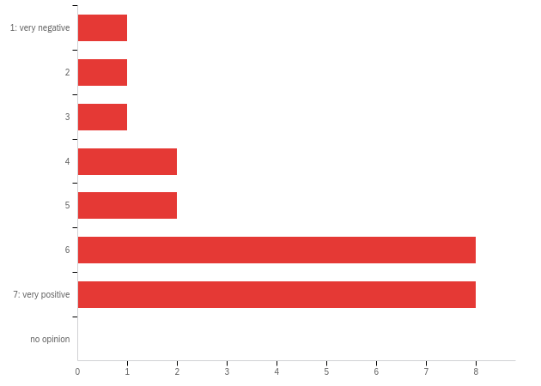

|  |  |  |  |  |  |  |  |
| --- | --- | --- | --- | --- | --- | --- | --- |
| # | Field | Minimum | Maximum | Mean | Std Deviation | Variance | Count |
| 1 | When it comes to the conference venue (building and facilities) my evaluation is: | 1.00 | 7.00 | 5.57 | 1.66 | 2.77 | 23 |

|  |  |  |  |
| --- | --- | --- | --- |
| # | Answer | % | Count |
| 1 | 1: very negative | 4.35% | 1 |
| 2 | 2 | 4.35% | 1 |
| 3 | 3 | 4.35% | 1 |
| 4 | 4 | 8.70% | 2 |
| 5 | 5 | 8.70% | 2 |
| 6 | 6 | 34.78% | 8 |
| 7 | 7: very positive | 34.78% | 8 |
| 8 | no opinion | 0.00% | 0 |
|  | Total | 100% | 23 |

**Q46 - Additional comments**

|  |
| --- |
| Additional comments |
| great (see above) |
| Very expensive venue to stay, to eat, and to reach... |
| No sound insulation between session rooms, screen projector quality is not that good |
| The building and facilities were sufficient for our purposes, however it would have been better to have it at a cheaper location (e.g. University in Albuqueque) so that lunch could be provided. |
| I loved that there were lots of areas, both inside and out, to congregate and chat. |
| Did not have VGA adapters on projectors. |
| It would have been more stimulating in a research environment - In iceland, it generated nice encounters and interactions |
| ISDC is consistently one of the most expensive conferences I attend. While providing food for the poster session was a brilliant innovation, I think the seat down banquet is a bit too much. |

**Q4 - When it comes to conference social activities (such as welcome reception, dinner and family/ guest activities) my evaluation is:**

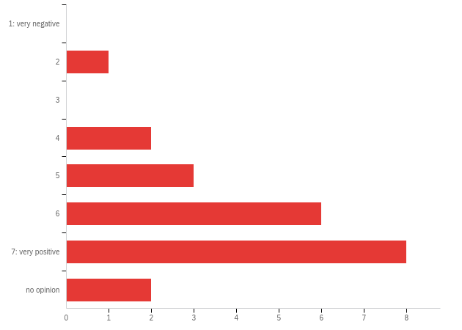

|  |  |  |  |  |  |  |  |
| --- | --- | --- | --- | --- | --- | --- | --- |
| # | Field | Minimum | Maximum | Mean | Std Deviation | Variance | Count |
| 1 | When it comes to conference social activities (such as welcome reception, dinner and family/ guest activities) my evaluation is: | 2.00 | 8.00 | 6.05 | 1.40 | 1.95 | 22 |

|  |  |  |  |
| --- | --- | --- | --- |
| # | Answer | % | Count |
| 1 | 1: very negative | 0.00% | 0 |
| 2 | 2 | 4.55% | 1 |
| 3 | 3 | 0.00% | 0 |
| 4 | 4 | 9.09% | 2 |
| 5 | 5 | 13.64% | 3 |
| 6 | 6 | 27.27% | 6 |
| 7 | 7: very positive | 36.36% | 8 |
| 8 | no opinion | 9.09% | 2 |
|  | Total | 100% | 22 |

**Q4b - Additional comments**

|  |
| --- |
| Additional comments |
| very friendly, well organized. |
| There was a clash in the programme. Since I was presenting at the Poster session at the SD Colloquium I wasnt able to attend the welcome reception. The conference dinner was delicious but the table decor was lacking. |
| welcome reception and colloquium poster presentation should be on the same location. |
| A bit too Formal |

**Q5 - When it comes to overall value my evaluation is:**

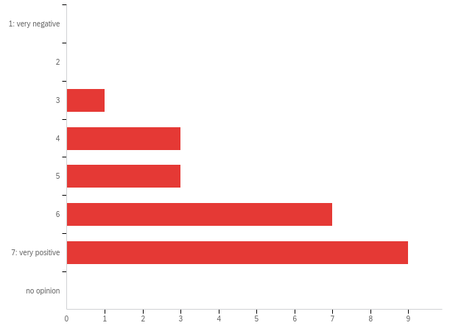

|  |  |  |  |  |  |  |  |
| --- | --- | --- | --- | --- | --- | --- | --- |
| # | Field | Minimum | Maximum | Mean | Std Deviation | Variance | Count |
| 1 | When it comes to overall value my evaluation is: | 3.00 | 7.00 | 5.87 | 1.19 | 1.42 | 23 |

|  |  |  |  |
| --- | --- | --- | --- |
| # | Answer | % | Count |
| 1 | 1: very negative | 0.00% | 0 |
| 2 | 2 | 0.00% | 0 |
| 3 | 3 | 4.35% | 1 |
| 4 | 4 | 13.04% | 3 |
| 5 | 5 | 13.04% | 3 |
| 6 | 6 | 30.43% | 7 |
| 7 | 7: very positive | 39.13% | 9 |
| 8 | no opinion | 0.00% | 0 |
|  | Total | 100% | 23 |

**Q5b - Additional comments**

|  |
| --- |
| Additional comments |
| great but expensive |
| The Colloquium and ISDC was an invaluable experience to me as a PhD student and junior system dynamicist. As a result of the relationships I established, I will be participating in the upcoming System Dynamics Modelling Process course at the University of Bergen. |
| Higher quality papers and presentations, especially in the plenaries, will help a lot. |

**Q6 - When it comes to the conference fee my evaluation is:**

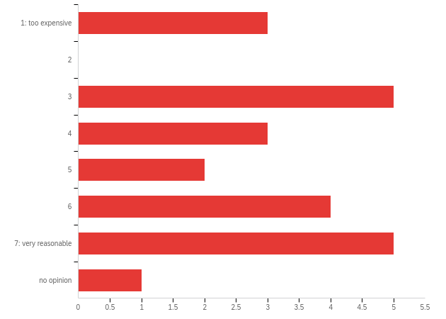

|  |  |  |  |  |  |  |  |
| --- | --- | --- | --- | --- | --- | --- | --- |
| # | Field | Minimum | Maximum | Mean | Std Deviation | Variance | Count |
| 1 | When it comes to the conference fee my evaluation is: | 1.00 | 8.00 | 4.65 | 2.10 | 4.40 | 23 |

|  |  |  |  |
| --- | --- | --- | --- |
| # | Answer | % | Count |
| 1 | 1: too expensive | 13.04% | 3 |
| 2 | 2 | 0.00% | 0 |
| 3 | 3 | 21.74% | 5 |
| 4 | 4 | 13.04% | 3 |
| 5 | 5 | 8.70% | 2 |
| 6 | 6 | 17.39% | 4 |
| 7 | 7: very reasonable | 21.74% | 5 |
| 8 | no opinion | 4.35% | 1 |
|  | Total | 100% | 23 |

**Q6b - Additional comments**

|  |
| --- |
| Additional comments |
| Conference fee did not include any lunch, and had only 1 "real" dinner. |
| It's reasonable, but could have included lunch package |
| The cost of the registration and getting to the States from South Africa was high. I am grateful for the conference scholarship from the SDS as this covered my registration fees. I also received a grant from a external source to cover my conference travel costs. |
| Could be cheaper for students coming from third world countries - Or first time attendee , so that more persons from all over the world could attend |

**Q7 - When it comes to the overnight accommodation my evaluation is:**

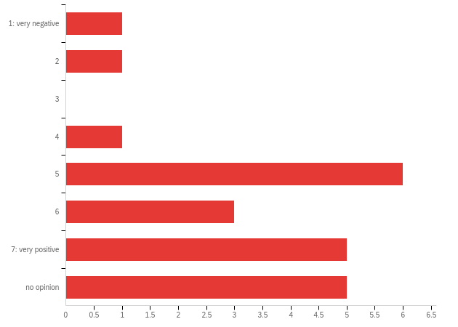

|  |  |  |  |  |  |  |  |
| --- | --- | --- | --- | --- | --- | --- | --- |
| # | Field | Minimum | Maximum | Mean | Std Deviation | Variance | Count |
| 1 | When it comes to the overnight accommodation my evaluation is: | 1.00 | 8.00 | 5.91 | 1.86 | 3.45 | 22 |

|  |  |  |  |
| --- | --- | --- | --- |
| # | Answer | % | Count |
| 1 | 1: very negative | 4.55% | 1 |
| 2 | 2 | 4.55% | 1 |
| 3 | 3 | 0.00% | 0 |
| 4 | 4 | 4.55% | 1 |
| 5 | 5 | 27.27% | 6 |
| 6 | 6 | 13.64% | 3 |
| 7 | 7: very positive | 22.73% | 5 |
| 8 | no opinion | 22.73% | 5 |
|  | Total | 100% | 22 |

**Q7b - Please indicate whether you used a hotel, hostel or AirBnB and the name of your accommodation if applicable. Please also list any additional comments you would like to make**

|  |
| --- |
| Please indicate whether you used a hotel, hostel or AirBnB and the name of your accommodation if applicable. Please also list any additional comments you would like to make |
| conference hotel |
| not the hotel where the conference was held, used budget hotel (70 USD per night) |
| AirBnB |
| I used a hostel to make it cheaper but I am regretful about that choice. I stayed in the Mother Road Hostel, in a private room and it was not a clean place at all to stay. |
| I used air BnB. My college does not provide enough financial support to cover food and hotel costs. |
| Hotel, Albuquerque |
| I stayed in an airbnb 5 min walk away from the Hotel. |
| We used AirBnb and had a great experience. |
| I sayed in Hilton in downtown. |
| Hotel Albuquerque |
| Hotel Albuquerque |
| I used the conference hotel |
| AirBnB |
| AirBnb |
| Hotel Albuquerque. |
| Hotel Albuquerque |

**Q8 - When it comes to the conference printed Program Schedule received at registration my evaluation is:**

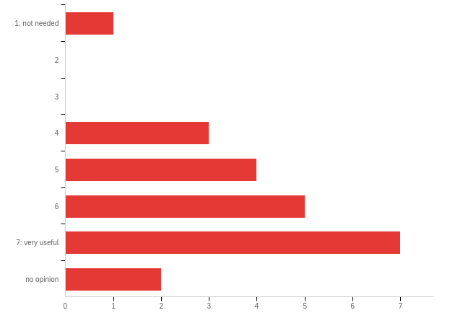

|  |  |  |  |  |  |  |  |
| --- | --- | --- | --- | --- | --- | --- | --- |
| # | Field | Minimum | Maximum | Mean | Std Deviation | Variance | Count |
| 1 | When it comes to the conference printed Program Schedule received at registration my evaluation is: | 1.00 | 8.00 | 5.82 | 1.59 | 2.51 | 22 |

|  |  |  |  |
| --- | --- | --- | --- |
| # | Answer | % | Count |
| 1 | 1: not needed | 4.55% | 1 |
| 2 | 2 | 0.00% | 0 |
| 3 | 3 | 0.00% | 0 |
| 4 | 4 | 13.64% | 3 |
| 5 | 5 | 18.18% | 4 |
| 6 | 6 | 22.73% | 5 |
| 7 | 7: very useful | 31.82% | 7 |
| 8 | no opinion | 9.09% | 2 |
|  | Total | 100% | 22 |

**Q72 - When it comes to the conference Online Program and access to presented work my evaluation is:**

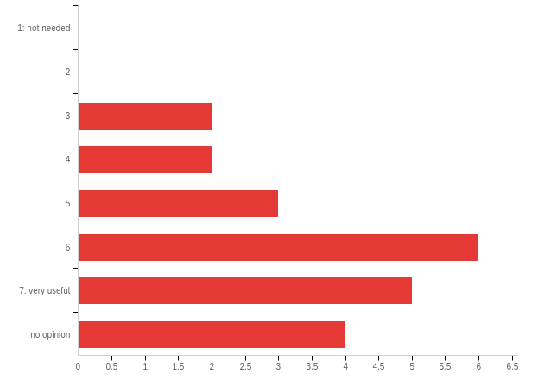

|  |  |  |  |  |  |  |  |
| --- | --- | --- | --- | --- | --- | --- | --- |
| # | Field | Minimum | Maximum | Mean | Std Deviation | Variance | Count |
| 1 | When it comes to the conference Online Program and access to presented work my evaluation is: | 3.00 | 8.00 | 6.00 | 1.51 | 2.27 | 22 |

|  |  |  |  |
| --- | --- | --- | --- |
| # | Answer | % | Count |
| 1 | 1: not needed | 0.00% | 0 |
| 2 | 2 | 0.00% | 0 |
| 3 | 3 | 9.09% | 2 |
| 4 | 4 | 9.09% | 2 |
| 5 | 5 | 13.64% | 3 |
| 6 | 6 | 27.27% | 6 |
| 7 | 7: very useful | 22.73% | 5 |
| 8 | no opinion | 18.18% | 4 |
|  | Total | 100% | 22 |

**Q0b - The following questions concern the plenary sessions.**



|  |  |  |  |  |  |  |  |
| --- | --- | --- | --- | --- | --- | --- | --- |
| # | Field | Minimum | Maximum | Mean | Std Deviation | Variance | Count |
| 1 | The following questions concern the plenary sessions. | 0.00 | 0.00 | 0.00 | 0.00 | 0.00 | 0 |

|  |  |  |
| --- | --- | --- |
| Answer | % | Count |
| Total | 100% | undefined |

**Q8b - Additional comments**

|  |
| --- |
| Additional comments |
| online access was confusing. The conference payment did not go smoothly not sure what happened. |
| Some plenairy sessions referred to very old research and used some very complex jargon which made the presentation not relevant for me |
| Arguably, PowerPoint presentations are not the most effective way to convey information. But if they are used, then the text on the slides should be large enough to be seen by everyone in the room. Although I am a fan of white space, white space and unreadably small text is not effective for communication. |

**Q10 - Are the plenary sessions too short or too long?**

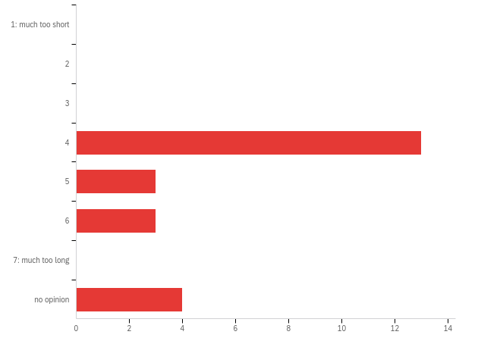

|  |  |  |  |  |  |  |  |
| --- | --- | --- | --- | --- | --- | --- | --- |
| # | Field | Minimum | Maximum | Mean | Std Deviation | Variance | Count |
| 1 | Are the plenary sessions too short or too long? | 4.00 | 8.00 | 5.09 | 1.50 | 2.25 | 23 |

|  |  |  |  |
| --- | --- | --- | --- |
| # | Answer | % | Count |
| 1 | 1: much too short | 0.00% | 0 |
| 2 | 2 | 0.00% | 0 |
| 3 | 3 | 0.00% | 0 |
| 4 | 4 | 56.52% | 13 |
| 5 | 5 | 13.04% | 3 |
| 6 | 6 | 13.04% | 3 |
| 7 | 7: much too long | 0.00% | 0 |
| 8 | no opinion | 17.39% | 4 |
|  | Total | 100% | 23 |

**Q11 - Should we have more or fewer plenary sessions?**

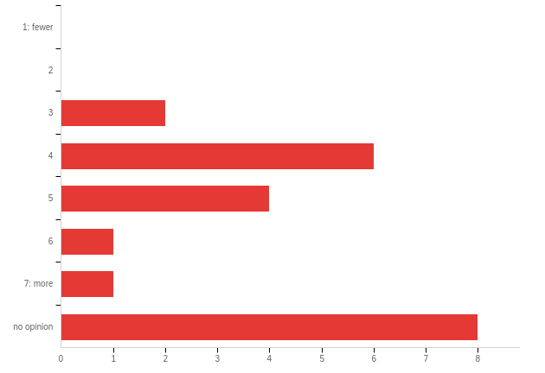

|  |  |  |  |  |  |  |  |
| --- | --- | --- | --- | --- | --- | --- | --- |
| # | Field | Minimum | Maximum | Mean | Std Deviation | Variance | Count |
| 1 | Should we have more or fewer plenary sessions? | 3.00 | 8.00 | 5.77 | 1.88 | 3.54 | 22 |

|  |  |  |  |
| --- | --- | --- | --- |
| # | Answer | % | Count |
| 1 | 1: fewer | 0.00% | 0 |
| 2 | 2 | 0.00% | 0 |
| 3 | 3 | 9.09% | 2 |
| 4 | 4 | 27.27% | 6 |
| 5 | 5 | 18.18% | 4 |
| 6 | 6 | 4.55% | 1 |
| 7 | 7: more | 4.55% | 1 |
| 8 | no opinion | 36.36% | 8 |
|  | Total | 100% | 22 |

**Q0c - The following questions concern the parallel and poster sessions.**



|  |  |  |  |  |  |  |  |
| --- | --- | --- | --- | --- | --- | --- | --- |
| # | Field | Minimum | Maximum | Mean | Std Deviation | Variance | Count |
| 1 | The following questions concern the parallel and poster sessions. | 0.00 | 0.00 | 0.00 | 0.00 | 0.00 | 0 |

|  |  |  |
| --- | --- | --- |
| Answer | % | Count |
| Total | 100% | undefined |

**Q13 - Are the parallel sessions too short or too long?**

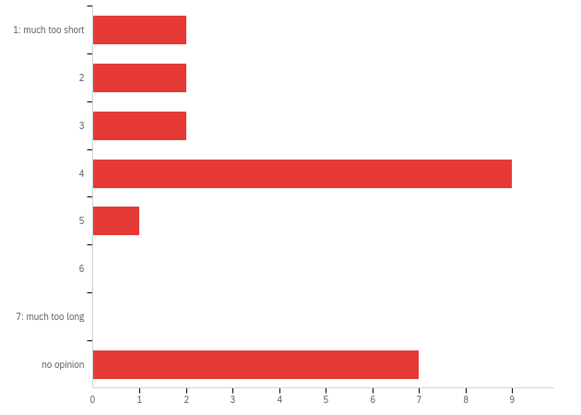

|  |  |  |  |  |  |  |  |
| --- | --- | --- | --- | --- | --- | --- | --- |
| # | Field | Minimum | Maximum | Mean | Std Deviation | Variance | Count |
| 1 | Are the parallel sessions too short or too long? | 1.00 | 8.00 | 4.74 | 2.36 | 5.58 | 23 |

|  |  |  |  |
| --- | --- | --- | --- |
| # | Answer | % | Count |
| 1 | 1: much too short | 8.70% | 2 |
| 2 | 2 | 8.70% | 2 |
| 3 | 3 | 8.70% | 2 |
| 4 | 4 | 39.13% | 9 |
| 5 | 5 | 4.35% | 1 |
| 6 | 6 | 0.00% | 0 |
| 7 | 7: much too long | 0.00% | 0 |
| 8 | no opinion | 30.43% | 7 |
|  | Total | 100% | 23 |

**Q14 - Should we have more or fewer parallel sessions?**

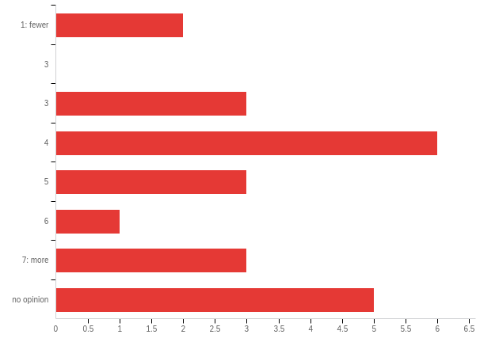

|  |  |  |  |  |  |  |  |
| --- | --- | --- | --- | --- | --- | --- | --- |
| # | Field | Minimum | Maximum | Mean | Std Deviation | Variance | Count |
| 1 | Should we have more or fewer parallel sessions? | 1.00 | 8.00 | 5.09 | 2.17 | 4.69 | 23 |

|  |  |  |  |
| --- | --- | --- | --- |
| # | Answer | % | Count |
| 1 | 1: fewer | 8.70% | 2 |
| 2 | 3 | 0.00% | 0 |
| 3 | 3 | 13.04% | 3 |
| 4 | 4 | 26.09% | 6 |
| 5 | 5 | 13.04% | 3 |
| 6 | 6 | 4.35% | 1 |
| 7 | 7: more | 13.04% | 3 |
| 8 | no opinion | 21.74% | 5 |
|  | Total | 100% | 23 |

**Q15 - Most posters are presented on Monday at the Poster Symposium and Reception. How satisfied are you with the poster sessions?**

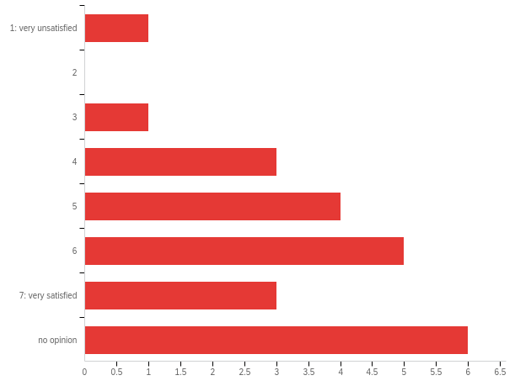

|  |  |  |  |  |  |  |  |
| --- | --- | --- | --- | --- | --- | --- | --- |
| # | Field | Minimum | Maximum | Mean | Std Deviation | Variance | Count |
| 1 | Most posters are presented on Monday at the Poster Symposium and Reception. How satisfied are you with the poster sessions? | 1.00 | 8.00 | 5.87 | 1.83 | 3.33 | 23 |

|  |  |  |  |
| --- | --- | --- | --- |
| # | Answer | % | Count |
| 1 | 1: very unsatisfied | 4.35% | 1 |
| 2 | 2 | 0.00% | 0 |
| 3 | 3 | 4.35% | 1 |
| 4 | 4 | 13.04% | 3 |
| 5 | 5 | 17.39% | 4 |
| 6 | 6 | 21.74% | 5 |
| 7 | 7: very satisfied | 13.04% | 3 |
| 8 | no opinion | 26.09% | 6 |
|  | Total | 100% | 23 |

**Q75 - How satisfied are you with the work in progress (WIP) sessions?**

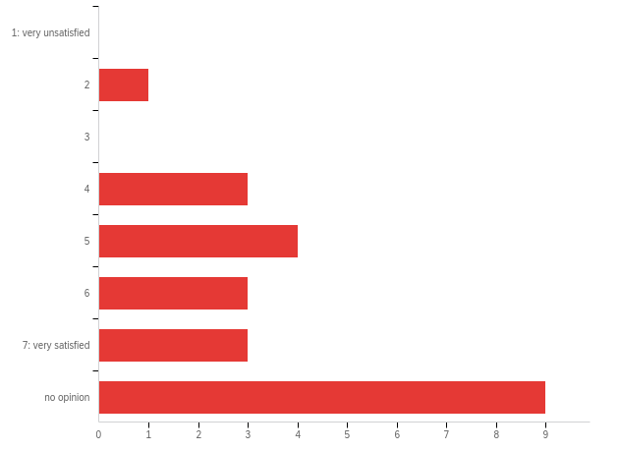

|  |  |  |  |  |  |  |  |
| --- | --- | --- | --- | --- | --- | --- | --- |
| # | Field | Minimum | Maximum | Mean | Std Deviation | Variance | Count |
| 1 | How satisfied are you with the work in progress (WIP) sessions? | 5.00 | 11.00 | 9.30 | 1.73 | 2.99 | 23 |

|  |  |  |  |
| --- | --- | --- | --- |
| # | Answer | % | Count |
| 4 | 1: very unsatisfied | 0.00% | 0 |
| 5 | 2 | 4.35% | 1 |
| 6 | 3 | 0.00% | 0 |
| 7 | 4 | 13.04% | 3 |
| 8 | 5 | 17.39% | 4 |
| 9 | 6 | 13.04% | 3 |
| 10 | 7: very satisfied | 13.04% | 3 |
| 11 | no opinion | 39.13% | 9 |
|  | Total | 100% | 23 |

**Q77 - To what extent do the work in progress (WIP) sessions add value to the conference program?**

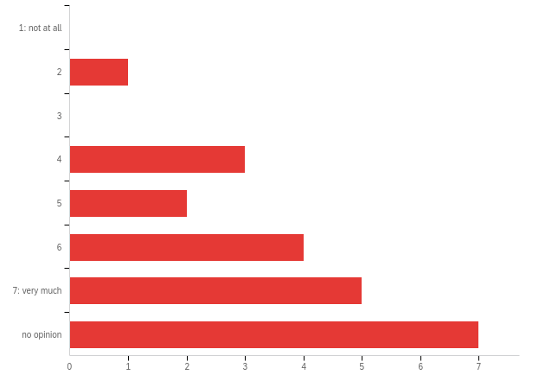

|  |  |  |  |  |  |  |  |
| --- | --- | --- | --- | --- | --- | --- | --- |
| # | Field | Minimum | Maximum | Mean | Std Deviation | Variance | Count |
| 1 | To what extent do the work in progress (WIP) sessions add value to the conference program? | 2.00 | 8.00 | 6.32 | 1.66 | 2.76 | 22 |

|  |  |  |  |
| --- | --- | --- | --- |
| # | Answer | % | Count |
| 1 | 1: not at all | 0.00% | 0 |
| 2 | 2 | 4.55% | 1 |
| 3 | 3 | 0.00% | 0 |
| 4 | 4 | 13.64% | 3 |
| 5 | 5 | 9.09% | 2 |
| 6 | 6 | 18.18% | 4 |
| 7 | 7: very much | 22.73% | 5 |
| 8 | no opinion | 31.82% | 7 |
|  | Total | 100% | 22 |

**Q76 - How satisfied are you with the feedback sessions?**

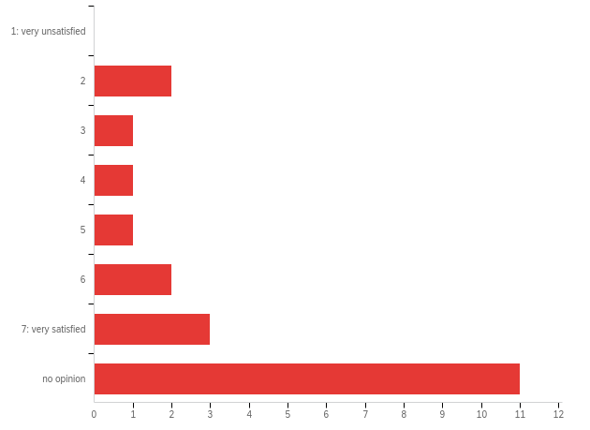

|  |  |  |  |  |  |  |  |
| --- | --- | --- | --- | --- | --- | --- | --- |
| # | Field | Minimum | Maximum | Mean | Std Deviation | Variance | Count |
| 1 | How satisfied are you with the feedback sessions? | 2.00 | 8.00 | 6.52 | 2.04 | 4.15 | 21 |

|  |  |  |  |
| --- | --- | --- | --- |
| # | Answer | % | Count |
| 1 | 1: very unsatisfied | 0.00% | 0 |
| 2 | 2 | 9.52% | 2 |
| 3 | 3 | 4.76% | 1 |
| 4 | 4 | 4.76% | 1 |
| 5 | 5 | 4.76% | 1 |
| 6 | 6 | 9.52% | 2 |
| 7 | 7: very satisfied | 14.29% | 3 |
| 8 | no opinion | 52.38% | 11 |
|  | Total | 100% | 21 |

**Q78 - To what extent do the feedback sessions add value to the conference program?**

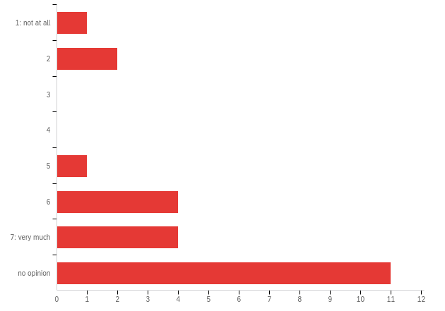

|  |  |  |  |  |  |  |  |
| --- | --- | --- | --- | --- | --- | --- | --- |
| # | Field | Minimum | Maximum | Mean | Std Deviation | Variance | Count |
| 1 | To what extent do the feedback sessions add value to the conference program? | 1.00 | 8.00 | 6.52 | 2.08 | 4.34 | 23 |

|  |  |  |  |
| --- | --- | --- | --- |
| # | Answer | % | Count |
| 1 | 1: not at all | 4.35% | 1 |
| 2 | 2 | 8.70% | 2 |
| 3 | 3 | 0.00% | 0 |
| 4 | 4 | 0.00% | 0 |
| 5 | 5 | 4.35% | 1 |
| 6 | 6 | 17.39% | 4 |
| 7 | 7: very much | 17.39% | 4 |
| 8 | no opinion | 47.83% | 11 |
|  | Total | 100% | 23 |

**Q70 - Which type of poster session or sessions do you prefer?**

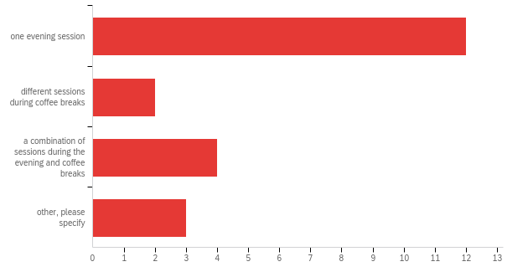

|  |  |  |  |  |  |  |  |
| --- | --- | --- | --- | --- | --- | --- | --- |
| # | Field | Minimum | Maximum | Mean | Std Deviation | Variance | Count |
| 1 | Which type of poster session or sessions do you prefer? - Selected Choice | 1.00 | 4.00 | 1.90 | 1.15 | 1.32 | 21 |

|  |  |  |  |
| --- | --- | --- | --- |
| # | Answer | % | Count |
| 1 | one evening session | 57.14% | 12 |
| 2 | different sessions during coffee breaks | 9.52% | 2 |
| 3 | a combination of sessions during the evening and coffee breaks | 19.05% | 4 |
| 4 | other, please specify | 14.29% | 3 |
|  | Total | 100% | 21 |

Q70_4_TEXT - other, please specify

|  |
| --- |
| other, please specify - Text |
| model and publishing feedback sessions |
| but not at the same time as the reception |
| I prefer one daytime session. Evening session made me very tired. Time duration is too long. Many people went back to hotels before the closing time. |

**Q16 - If you could make any other changes to the format of the sessions, what would those changes be?**

|  |
| --- |
| If you could make any other changes to the format of the sessions, what would those changes be? |
| Q&A for each presentation should be after the presentation itself, instead of a combined session at the end. Especially in the parallel sessions of this year, most session chairs preferred the latter format. |
| Welcome reception should not take place at the same time as the SD Colloquium please |
| Format is OK. However, parallel and poster submissions should be by extended abstracts because proceedings don't include full paper. |
| None |
| The idea of feedback sessions is very good; however I do not like the current format at all. The author should give a short explanation on his or her work and the reviewed shoud provide constructive feedback. With respect to the planary sessions I have to make hard choises between certain sessions because many interessing sessions were on the same time slot. |
| I would schedule the Psychology and Human Behavior SIG Meeting at a different time than the Social Impact SIG meeting since there is a strong overlap in interest. Consider this also for other SIG meetings |
| Format variety is good. The big issue isn't the format but boosting the quality in all categories. WIP sessions need higher standards - WIP should be far enough along that there are prelim results or at least a clear, compelling problem definition and specific proposed methodology. A causal diagram about some issue without a clear purpose and problem to be addressed is not useful and limits the ability of any who attend to ask useful questions that might help the authors. |

**Q73 - The following question concerns the overall quality of the presented work (in plenary, parellel, poster and other sessions). How do you rate the overall quality of the presented work?**

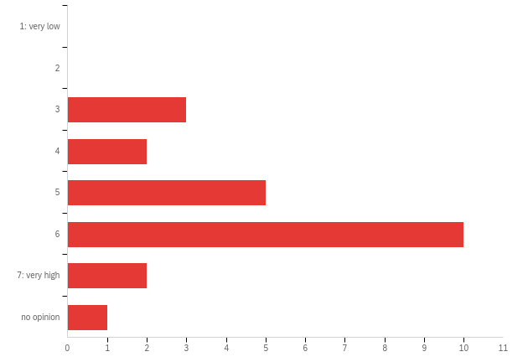

|  |  |  |  |  |  |  |  |
| --- | --- | --- | --- | --- | --- | --- | --- |
| # | Field | Minimum | Maximum | Mean | Std Deviation | Variance | Count |
| 1 | The following question concerns the overall quality of the presented work (in plenary, parellel, poster and other sessions). How do you rate the overall quality of the presented work? | 7.00 | 12.00 | 9.39 | 1.28 | 1.63 | 23 |

|  |  |  |  |
| --- | --- | --- | --- |
| # | Answer | % | Count |
| 1 | 1: very low | 0.00% | 0 |
| 6 | 2 | 0.00% | 0 |
| 7 | 3 | 13.04% | 3 |
| 8 | 4 | 8.70% | 2 |
| 9 | 5 | 21.74% | 5 |
| 10 | 6 | 43.48% | 10 |
| 11 | 7: very high | 8.70% | 2 |
| 12 | no opinion | 4.35% | 1 |
|  | Total | 100% | 23 |

**Q0d - The following questions address the conference in a more general sense.**



|  |  |  |  |  |  |  |  |
| --- | --- | --- | --- | --- | --- | --- | --- |
| # | Field | Minimum | Maximum | Mean | Std Deviation | Variance | Count |
| 1 | The following questions address the conference in a more general sense. | 0.00 | 0.00 | 0.00 | 0.00 | 0.00 | 0 |

|  |  |  |
| --- | --- | --- |
| Answer | % | Count |
| Total | 100% | undefined |

**Q55 - What is your opinion about the duration of the breaks during the conference?**

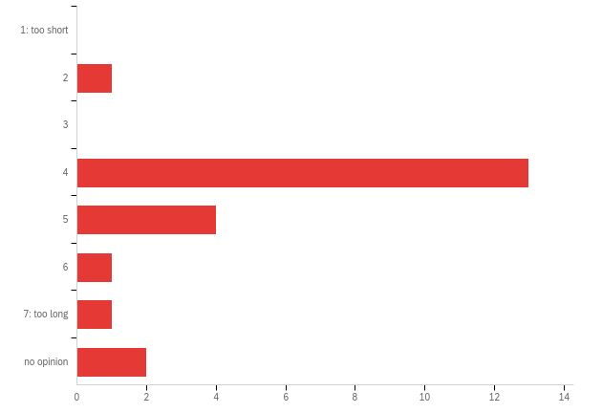

|  |  |  |  |  |  |  |  |
| --- | --- | --- | --- | --- | --- | --- | --- |
| # | Field | Minimum | Maximum | Mean | Std Deviation | Variance | Count |
| 1 | What is your opinion about the duration of the breaks during the conference? | 2.00 | 8.00 | 4.68 | 1.39 | 1.94 | 22 |

|  |  |  |  |
| --- | --- | --- | --- |
| # | Answer | % | Count |
| 1 | 1: too short | 0.00% | 0 |
| 2 | 2 | 4.55% | 1 |
| 3 | 3 | 0.00% | 0 |
| 4 | 4 | 59.09% | 13 |
| 5 | 5 | 18.18% | 4 |
| 6 | 6 | 4.55% | 1 |
| 7 | 7: too long | 4.55% | 1 |
| 8 | no opinion | 9.09% | 2 |
|  | Total | 100% | 22 |

**Q17 - Would you like to see more or less academic work (as compared to applications)?**

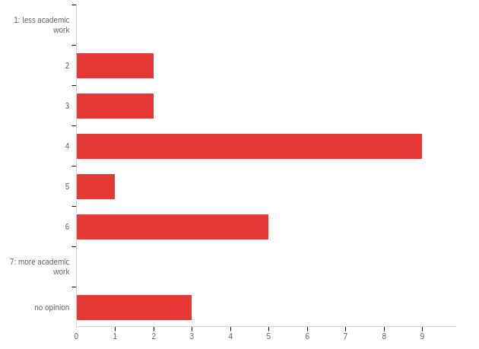

|  |  |  |  |  |  |  |  |
| --- | --- | --- | --- | --- | --- | --- | --- |
| # | Field | Minimum | Maximum | Mean | Std Deviation | Variance | Count |
| 1 | Would you like to see more or less academic work (as compared to applications)? | 2.00 | 8.00 | 4.77 | 1.73 | 2.99 | 22 |

|  |  |  |  |
| --- | --- | --- | --- |
| # | Answer | % | Count |
| 1 | 1: less academic work | 0.00% | 0 |
| 2 | 2 | 9.09% | 2 |
| 3 | 3 | 9.09% | 2 |
| 4 | 4 | 40.91% | 9 |
| 5 | 5 | 4.55% | 1 |
| 6 | 6 | 22.73% | 5 |
| 7 | 7: more academic work | 0.00% | 0 |
| 8 | no opinion | 13.64% | 3 |
|  | Total | 100% | 22 |

**Q18 - ​How satisfied are you with the workshops?**

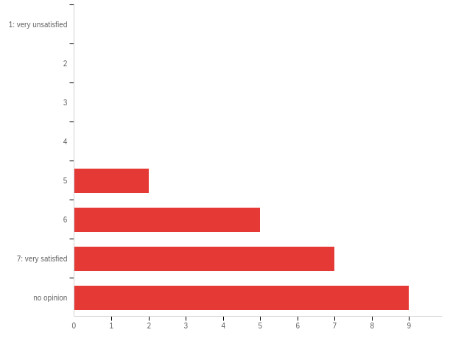

|  |  |  |  |  |  |  |  |
| --- | --- | --- | --- | --- | --- | --- | --- |
| # | Field | Minimum | Maximum | Mean | Std Deviation | Variance | Count |
| 1 | ​How satisfied are you with the workshops? | 5.00 | 8.00 | 7.00 | 0.98 | 0.96 | 23 |

|  |  |  |  |
| --- | --- | --- | --- |
| # | Answer | % | Count |
| 1 | 1: very unsatisfied | 0.00% | 0 |
| 2 | 2 | 0.00% | 0 |
| 3 | 3 | 0.00% | 0 |
| 4 | 4 | 0.00% | 0 |
| 5 | 5 | 8.70% | 2 |
| 6 | 6 | 21.74% | 5 |
| 7 | 7: very satisfied | 30.43% | 7 |
| 8 | no opinion | 39.13% | 9 |
|  | Total | 100% | 23 |

**Q52 - If you could make changes to the format of the workshops, what would those changes be?**

|  |
| --- |
| If you could make changes to the format of the workshops, what would those changes be? |
| I would prefer that the workshops are spread out during the conference as I was not able to attend all workshops I was interested in. Workshop on tool to document the model was very helpful. |
| None |
| none |
| More time for workshops (maybe 1.5 days?) |

**Q19 - What, specifically, do you value about coming to the conference?**

|  |
| --- |
| What, specifically, do you value about coming to the conference? |
| Meeting with colleagues |
| I really valued the opportunity to meet more SD folks and to get assistance with my model, as well as present my work. While the intermediate track of the summer school could have been a little better, I really valued the opportunity for learning and the opportunity to form relationships with more senior system dynamicists. |
| Motivation for the field |
| Great networking opportunities, quality work, good mix of academics and non-academics |
| Learning the research method. Learning from the presentations, talking with authors and exhibitors, and attending the workshops. |
| 1. Opportunity to present my work and discuss the topics of my interest with peers! 2. See work done by others, news, achievements, technology, ... ! 3. Networking and new opportunities! |
| The relationships I formed with both senior and junior system dynamicists. I was a volunteer during the SD Colloquium which helped me get to know people. |
| Networking. |
| seeing societies working area.. |
| Getting the newest research topics, modeling technique, and software news, and networking. |
| Networking |
| feedback on my work; sharing throughts with peer researchers and practitioners; explore future opportunities |
| personal interactions |
| Networking, supporting the Colloquium, hearing about new work |
| Linking again with the people that attend often to those conferences and share the progress |
| Interaction with workers in the field. |
| Appreciated coming to Albuquerque |
| Networking, opportunity to learn about the best work in the field (not currently satisfied sufficiently - many of the best people do not attend), opportunity to present |
| Networking, see good research work, workshops |

**Q20 - What was the best thing that happened to you at the conference?**

|  |
| --- |
| What was the best thing that happened to you at the conference? |
| great feedback about my presentation and those of my students |
| workshop, feedback sessions, meeting people, relevant (SDGs) conference topics |
| The modeling assistance workshops were really valuable and I'm so glad this is offered. I wasn't able to go to the publishing assistance workshops but they also seem very valuable. I also really appreciated the senior system dynamicists who participated in the SD Colloquium and went out of their way to mentor newer members. |
| Opportunity to network with fellow PhD and researchers, gaining insights about application of SD |
| Meeting people in person, having a chance to make personal contacts. |
| Diversification of ideas, approaches and subjects that might be interlinked with SD |
| I expressed my concern about being a PhD student specializing in palaeoecology who doesnt have any SD modelling supervision, as a result Prof Birgit Kopainsky extended an invitation to participate in the upcoming System Dynamics Modelling course at University of Bergen (5 Nov - 12 Dec 2019). |
| I had the opportunity to meet and talk with a variety of practitioners and academics in the field. As a first time attendee, I was thrilled with their willingness to give me their time and wisdom. |
| To know the cutting edge software news. |
| Talking science |
| well, I have had mutiple best moments. |
| met people. went on a hike. |
| Working with people as an angel advisor and participating in other Colloquium activities |
| Very nice and constructive feedbacks on my work, nice encounters as well |
| Interaction with workers in the field. |
| Meeting old friends |

**Q21 - What was the worst thing that happened to you at the conference?**

|  |
| --- |
| What was the worst thing that happened to you at the conference? |
| - |
| I don't think it was appropriate for the presenter of the Barry Richmond award to editorialize that the woman who won "didn't quite nail it." I'm sure it was unintentional but it was very condescending and undercuts her success. |
| Struggling to find a place for a quick lunch |
| Many presenters are not making their presentations, nor their papers, nor their models available to the conference attendees. I was forced to email authors to request their presentation/paper/model and none responded. This is a practice that will kill the Society. The SDS should have a policy that requires accepted authors to AT LEAST provide the presentation deck to the attendees (without people having to ask). |
| 1. Lack of cooperation with peers! It is very difficult to find experts who are ready to cooperate to develop certain ideas because most experts are concentrated on their own interests! |
| No lunch provided :( |
| No food available when I was hungry. |
| the problem with the break is that there is not time. there are always interesting meetings during break time |
| Some plenary speakers talked too fast. The society should ask speakers to talk slower and easy-to-understand-wording. It is "international" conference. Even for native speakers, too fast speaking is not understandable when it comes out of specialties. |
| I didn’t receive any information ahead of time about where to go. |
| None |
| It ended ;-) |
| speakers changed order without warning and I missed a talk. |
| None |
| My laptop crashed ... (worst souvenir ...) |
| Some of the plenary sessions. We should be using this session to present the best work done in the field and not to speculate about potential developments. |
| I should have attended the workshops. |
| Quality of work |

**Q0e - Background information**



|  |  |  |  |  |  |  |  |
| --- | --- | --- | --- | --- | --- | --- | --- |
| # | Field | Minimum | Maximum | Mean | Std Deviation | Variance | Count |
| 1 | Background information | 0.00 | 0.00 | 0.00 | 0.00 | 0.00 | 0 |

|  |  |  |
| --- | --- | --- |
| Answer | % | Count |
| Total | 100% | undefined |

**Q22 - Profession**

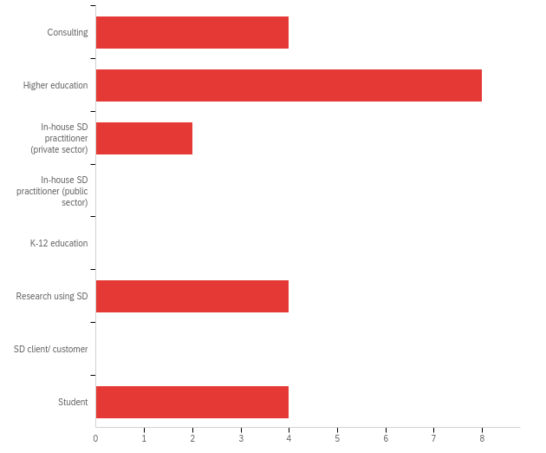

|  |  |  |  |  |  |  |  |
| --- | --- | --- | --- | --- | --- | --- | --- |
| # | Field | Minimum | Maximum | Mean | Std Deviation | Variance | Count |
| 1 | Profession | 1.00 | 8.00 | 3.73 | 2.60 | 6.74 | 22 |

|  |  |  |  |
| --- | --- | --- | --- |
| # | Answer | % | Count |
| 1 | Consulting | 18.18% | 4 |
| 2 | Higher education | 36.36% | 8 |
| 3 | In-house SD practitioner (private sector) | 9.09% | 2 |
| 4 | In-house SD practitioner (public sector) | 0.00% | 0 |
| 5 | K-12 education | 0.00% | 0 |
| 6 | Research using SD | 18.18% | 4 |
| 7 | SD client/ customer | 0.00% | 0 |
| 8 | Student | 18.18% | 4 |
|  | Total | 100% | 22 |

**Q23 - Other (please specify)**

|  |
| --- |
| Other (please specify) |
| Researcher using SD/Phd |
| Higher ed and research using SD |
| PhD Student |
| I am both SD practitioner and PhD student |
| Modeler, Life Coach, Trainer |

**Q24 - Fields of interest (please check all that apply)**

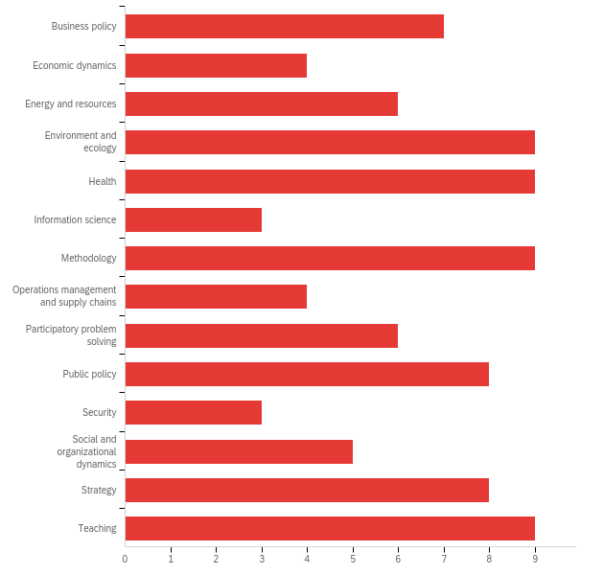

|  |  |  |  |
| --- | --- | --- | --- |
| # | Answer | % | Count |
| 1 | Business policy | 7.78% | 7 |
| 5 | Economic dynamics | 4.44% | 4 |
| 7 | Energy and resources | 6.67% | 6 |
| 8 | Environment and ecology | 10.00% | 9 |
| 4 | Health | 10.00% | 9 |
| 9 | Information science | 3.33% | 3 |
| 10 | Methodology | 10.00% | 9 |
| 11 | Operations management and supply chains | 4.44% | 4 |
| 12 | Participatory problem solving | 6.67% | 6 |
| 13 | Public policy | 8.89% | 8 |
| 14 | Security | 3.33% | 3 |
| 15 | Social and organizational dynamics | 5.56% | 5 |
| 3 | Strategy | 8.89% | 8 |
| 2 | Teaching | 10.00% | 9 |
|  | Total | 100% | 90 |

**Q47 - How often have you attended the SD conference before?**

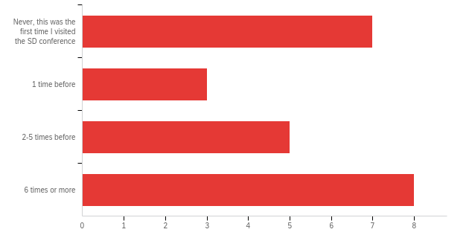

|  |  |  |  |  |  |  |  |
| --- | --- | --- | --- | --- | --- | --- | --- |
| # | Field | Minimum | Maximum | Mean | Std Deviation | Variance | Count |
| 1 | How often have you attended the SD conference before? | 1.00 | 4.00 | 2.61 | 1.24 | 1.54 | 23 |

|  |  |  |  |
| --- | --- | --- | --- |
| # | Answer | % | Count |
| 1 | Never, this was the first time I visited the SD conference | 30.43% | 7 |
| 2 | 1 time before | 13.04% | 3 |
| 3 | 2-5 times before | 21.74% | 5 |
| 4 | 6 times or more | 34.78% | 8 |
|  | Total | 100% | 23 |

**Q25 - Other (please specify)**

Other (please specify)

**Q26 - Residence**

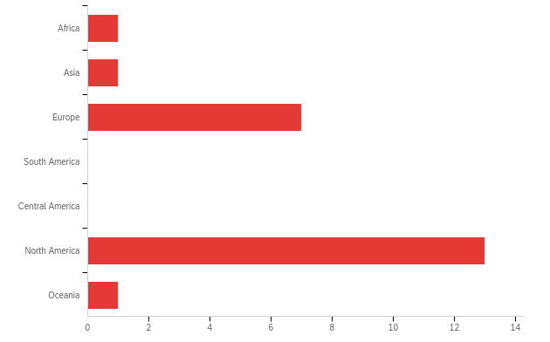

|  |  |  |  |  |  |  |  |
| --- | --- | --- | --- | --- | --- | --- | --- |
| # | Field | Minimum | Maximum | Mean | Std Deviation | Variance | Count |
| 1 | Residence | 1.00 | 7.00 | 4.74 | 1.72 | 2.98 | 23 |

|  |  |  |  |
| --- | --- | --- | --- |
| # | Answer | % | Count |
| 1 | Africa | 4.35% | 1 |
| 2 | Asia | 4.35% | 1 |
| 3 | Europe | 30.43% | 7 |
| 4 | South America | 0.00% | 0 |
| 5 | Central America | 0.00% | 0 |
| 6 | North America | 56.52% | 13 |
| 7 | Oceania | 4.35% | 1 |
|  | Total | 100% | 23 |

**Q27 - Other (please specify)**

|  |
| --- |
| Other (please specify) |
| Africa |

**Q28 - Years as a system dynamicist (student)**

|  |
| --- |
| Years as a system dynamicist (student) |
| 4 |
| 4 |
| 3 |
| 5 |
| 1.5 |
| 16 |
| 3 |
| 2 weeks |
| 2 |
| 0 |
| 4 |
| 4 |
| 4 |

**Q29 - Years as a system dynamicist (practitioner)**

|  |
| --- |
| Years as a system dynamicist (practitioner) |
| 12 |
| 1 |
| 2 |
| 16 |
| 4 |
| 0 |
| 2 |
| 26 |
| 0 |
| 12 |
| 4 |
| 3 |
| 10 |
| 28 |
| 30 |
| ~25 |

**Q68 - If you have any suggestions for improvements in the conference schedule (online or printed), please list them here.**

|  |
| --- |
| If you have any suggestions for improvements in the conference schedule (online or printed), please list them here. |
| If there is a conference management app in smartphone where participants can be notified when they selected the program that they wish to attend and getting around information, that would be really handy rather than distributing paper-based program. |
| Irrespective of online or printed, conference schedule should have session chair names and all co-authors name. |
| Add and keep the papers and not just the abstracts. Schedule simular-SIG meetings at different times. Open up the pre-conference courses to more instructors. Ask for proposals. |